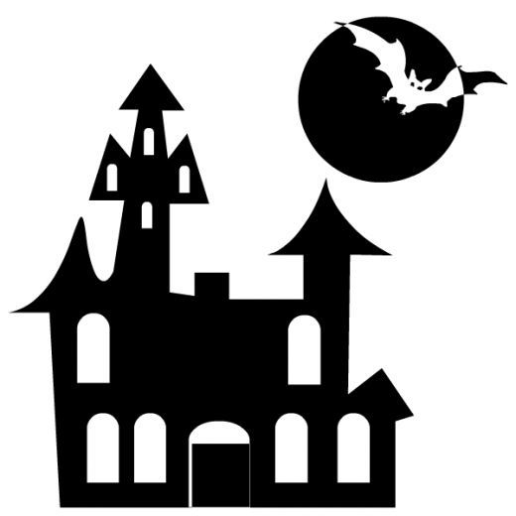
Haunted House
&
Spooky Wooded Trail

