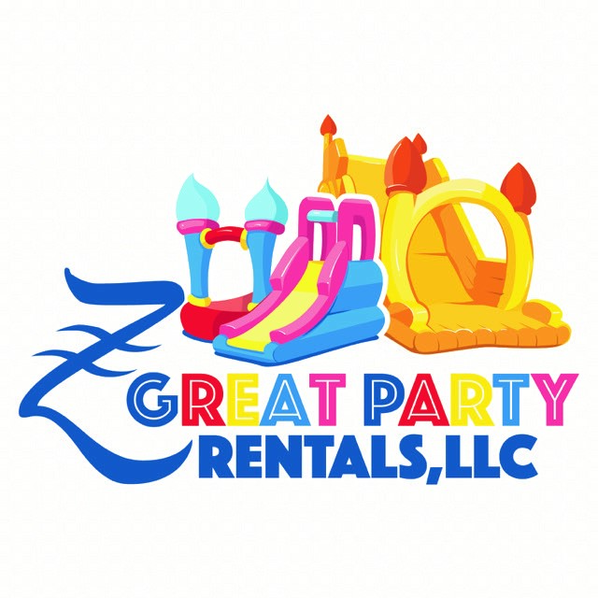
172 Stokes Landing Rd Saint Augustine, FL 32095
Rental Agreement, Hold Harmless Waiver

Rental Date:_____________________ Start Time:____________ End Time:_____________
Grass:___________ Concrete:__________ Other:____________
Product:___________________________________________________________
Rental Amount:_$_____________Deposit Paid:_$______________Balance Due:$___________
Customer Name:_____________________________ Ph#__________________________
Address:__________________________________________________________________

1.This rental equipment has been received in good condition and will be returned in the same condition (ordinary wear accepted)
2.Customer agrees the company the right to enter premises of customer at any time to repossess said equipment.
3.Customer agrees to reimburse Z Great Party Rentals, LLC for all attorney fees, an amount not less than 50% of all sums due, court costs, and expenses incurred by Z Great Party Rentals, LLC to enforce rights under this contract.
4.Customer agrees not to loan, sublet, or otherwise depose of equipment or use it at any other location.
5.Customer agrees to pay in full the replacement cost, including labor, for all damages to rental equipment.
6.If the inflatable equipment is lost, stolen or damaged beyond repair, the renter agrees to pay up to $4300.00. (forty-three dollars) to have the item replaced.
7.Customer agrees to ensure that all users (and users guardians) of the rental go over and read all the rules.
8. THERE ARE NO WARRANTIES OF MECHANTABILITY OR FITNESS EITHER EXPRESSED OR IMPLIED. The person/s or organization renting this equipment from Z Great Part Rentals, LLC will be held responsible and liable for any and all damage or injury occurring for any reason whatsoever. I have read the above agreement and fully understand and accept the conditions as above. I am aware that while in my care I am fully responsible for the inflatable and will pay for any loss or damaged that may occur.

?F%# &"!F%F%
F#,!, &D&((#, #,##,$D&,
&,,#& $ )?#(&Enter Company
Name (&,$,, #,,0 ,(,#
!$,#,!,!+&7(,#!&(D&,
#,   &,$%$#((
 ),!,(,$,"&, ,,
 $,( )?!&Enter Company Name(
D#(( )Enter Company Name ,
&,!!(D(  ,,,
$!&F%#)?#(&Enter
Company Name (&,#,G$( #(
&0(
?F%# &"!F%F%
F#,!, &D&((#, #,##,$D&,
&,,#& $ )?#(&Enter Company
Name (&,$,, #,,0 ,(,#
!$,#,!,!+&7(,#!&(D&,
#,   &,$%$#((
 ),!,(,$,"&, ,,
 $,( )?!&Enter Company Name(
D#(( )Enter Company Name ,
&,!!(D(  ,,,
$!&F%#)?#(&Enter
Company Name (&,#,G$( #(
&0(
E?F%# &"!F%F%
F#,!, &D&((#, #,##,$D&,
&,,#& $ )?#(&Enter Company
Name (&,$,, #,,0 ,(,#
!$,#,!,!+&7(,#!&(D&,
#,   &,$%$#((
 ),!,(,$,"&, ,,
 $,( )?!&Enter Company Name(
D#(( )Enter Company Name ,
&,!!(D(  ,,,
$!&F%#)?#(&Enter
Company Name (&,#,G$( #(
&0
E?F%# &"!F%F%
F#,!, &D&((#, #,##,$D&,
&,,#& $ )?#(&Enter Company
Name (&,$,, #,,0 ,(,#
!$,#,!,!+&7(,#!&(D&,
#,   &,$%$#((
 ),!,(,$,"&, ,,
 $,( )?!&Enter Company Name(
D#(( )Enter Company Name ,
&,!!(D(  ,,,
$!&F%#)?#(&Enter
Company Name (&,#,G$( #(
&0
E?F%# &"!F%F%
F#,!, &D&((#, #,##,$D&,
&,,#& $ )?#(&Enter Company
Name (&,$,, #,,0 ,(,#
!$,#,!,!+&7(,#!&(D&,
#,   &,$%$#((
 ),!,(,$,"&, ,,
 $,( )?!&Enter Company Name(
D#(( )Enter Company Name ,
&,!!(D(  ,,,
$!&F%#)?#(&Enter
Company Name (&,#,G$( #(
&0
9. Lessee understands and acknowledges that play on an amusement device entails both known and unknown risks including, but not limited to, physical injury from falling, slipping, crashing or colliding, emotional injury, paralysis, distress, damage or death to any participant. Lessee agrees to indemnify and hold Z Great Party Rentals, LLC harmless from any and all claims, actions, suits, proceedings, costs, expenses, fees, damages an liabilities, including but not limited to, reasonable attorney’s fees and costs, arising by reason of injury, damage, or death to person or persons property, in connection with or resulting from the use of the leased equipment. This includes but, is not limited to, the manufacturer, selection, delivery, possession, use, operation, or return of the equipment. Lessee hereby releases and holds harmless Z Great Party Rentals, LLC from injuries or damage incurred because of the use of the leased equipment. Z Great Party Rentals, LLC cannot, under any circumstances, be held liable for injuries because of inappropriate use, God, nature, or other conditions beyond its control or knowledge. Lessee also agrees to indemnify and hold harmless Z Great Party Rentals, LLC from any loss, damage, theft, or destruction of the equipment during the term of the lease and any extension thereof.

It is the responsibility of the person/s or organization hiring this inflatable equipment to ensure that all possible precautions are taken to avoid injury to people or damage to the inflatable. Please ensure the following safety instructions are followed:
- No food, drink or chewing gum on or around the inflatable. This will avoid a choking hazard and keep the unit clean. (Please note, that if the inflatable is collected in a dirty condition then the person hiring it will incur a cleaning charge)

- Shoes, glasses, jewelry, and badges MUST be removed before using the inflatable to avoid injury to people using the equipment and harm to the inflatable.

- No Face paints, party poppers, colored streamers, or SILLY STRING to be used either on or near that inflatable. (Please note, these products will cause damage to the inflatable that cannot be repaired)

- Only 1 rider allowed at the top of the waterslide at a time, or 2 riders for double lane slides, 6 riders per bounce house or combo unit.

- Z Great Party Rentals, LLC is not responsible for striking or damaging any underground utility lines/devise (included but not limited to electrical, plumbing, sprinkler, etc.) It is the lessee’s responsibility to tell Z Great Party Rentals, LLC where the inflatable is to be setup and have any underground utility lines marked prior, too. Once the inflatable is in place, it will not be moved until said the end of the rental period.

- Climbing, hanging, or sitting on walls is dangerous and must not be allowed.

- A responsible Adult 18+ must always supervise the inflatable.

- Always ensure that the inflatable is not overcrowded, and limit numbers according to age and size of children using it. Try to avoid large and small children from using it at the same time.

- Ensure children are not pushing, colliding, fighting, or behaving in a manner likely to injure or cause distress to others.

- No pets, toys, or sharp instruments on the inflatable at any time.

- Do not allow anyone to be on the inflatable equipment inflation or deflation as this is DANGEROUS.

- Do not allow anyone to bounce on the front safety step as this is DANGEROUS.

- Please ensure that children are not attempting somersaults and are clothed appropriately and that nothing can fall out of their pockets.

- If the blower stops working, please ensure all users get off the inflatable immediately and calmly. Check the fuses and make sure the blower tube or deflation tube has not come undone or something has not blown onto and is obstructing the blower. If it overheats, or loses power, switch the blower off at the mains, then switch it back on again 1 to 2 minutes later, and it should restart. If it does not, inform us immediately.

- The MOST IMPORTANT RULE: DO NOT let children play on the inflatable without adult supervision. Adult supervision is necessary to enforce these rules for safe operation on the inflatable.

Overnight Rentals
Lessee understands and acknowledge that the blower is to e removed from the inflatable device and locked in a secure location overnight. Initial/s __________________

By signing this agreement, I accept the Rental/Safety and Liability terms and conditions.

Lessee Printed Name: ______________________________________________
Lessee Signature:_________________________________________________Date:__________

Lessor Signature:_________________________________________________ Date:__________

Safety/How to Checklist
- I have been shown how the inflatable is secured. _______(initial)
- I have been shown how to turn on/off the blower. ___________ (initial)
- In the event of high winds exceeding 15mph or storms, I have been instructed to get all participants off the unit and unplug the motor and extension cord from the power outlet. ________ (initial)
- I have been instructed to not allow any horseplay, flips, wrestling, or any other unsafe activities both in and around inflatable. _________ (initial)
- I understand that adult (18+ years) operators must always be provided to watch the games. ___________ (initial)
- I have been advised that all children of the same age size group may use the unit(s) at any given time. ___________ (initial)
- Maximum number or riders of each group that should play in the unit at one time is 6 riders or a maximum weight of 600lbs-100lbs/ea. patron. Minimum height-36” and Maximum height-60” or if applicable see the inflatable warning tags/manual for weight/height restrictions if they vary from this disclosure. __________ (initial)
- All inflatables should be securely anchored and fully inflated before ay riders are allowed to enter. _________ (initial)
- I agree to remove any person from the inflatable who is violating posted rules of operation. ___________ (initial)
- I have received both written and verbal instruction on the safety rules. ________ (initial)
- Do not install inflatables near a pool. ________ (initial)
- Under no circumstances is climbing on the exterior of the inflatable allowed. ________(initial)

I have been advised of the following:
- SUPERVISION by a qualified attendant is required at all times.
- REMOVE shoes, eyeglasses and any sharp objects.
- No open flames near any inflatable unit (s)
- No food, drinks, gum, pets or silly string
- Somersaults, diving, wrestling rough play, and flips are prohibited
- When renting a slide, children should go down the slide FEET FIRST ONLY, one rider at a time for each line.
- Check anchors regularly during play to ensure they remain securely in the ground when using the unit (s) outdoors.
- DO NOT allow children to jump onto or off the unit (s)
- EXIT immediately if the unit begins to lose air.
- Z Great Party Rentals is not responsible for damaged grass after being covered from a tarp/inflatable.

Lessee Printed Name: ______________________________________________
Lessee Signature:_________________________________________________Date:__________

Lessor Signature:_________________________________________________ Date:__________

